

LOOKING FOR A WAY

TO GET INVOLVED IN PARISH EVENTS?

ENJOY SOCIAL

ACTIVITIES?

WANT TO ENRICH YOUR CATHOLIC

FAITH?

**For More Information Contact:**



**COLUMBIETTES**

**The Blue Circle represents the World.**

**The White Cross represents Christ’s Love for us – by His Crucifixion, He redeemed the World.**

**The Rays represent our zeal to serve God through the mediums of Faith, Hope and Charity; symbolized by the Three White Stars.**

**Founders**

# They ignited the spirit of the Columbiette Order; May we continue to kindle the flame!

In 1939 the Columbiettes were started by Msgr. J. Francis McIntyre (later Cardinal), who conceived an idea of a ladies’ organization to work with the Knights of Columbus.

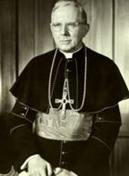

John Leo Coyle, PFN and Charles Maruca, PGK, were appointed to formulate a plan for this future group of Catholic women. The

Knights enlisted the aid of the

JOIN THE

COLUMBIETTES!

Honorable Margaret Mary J. Mangan an attorney who was the second woman to sit as a judge on the New York State Supreme Court.

Judge Mangan was elected the first President of the Supreme Council Columbiettes. She was a woman of greatness and humility and was dedicated to the Columbiettes.

The Columbiettes were always dear to her heart, and she brought honor and glory to the Columbiettes in all aspects of her career as a Supreme Court Justice and a Catholic woman.

The Columbiettes, following the example of their founders, dedicate themselves to do God’s work on earth promoting unity, Christ’s love for each of us, and zeal to serve God through Faith, Hope and Charity.

St. Joan of Arc

## Why Join?

The benefits of membership are many including spiritual, moral, charitable, educational and social. We pray for each other and play together building lasting friendships and crucial support systems in our lives.



**Get Involved with the Columbiettes!**

The Columbiettes are a growing service organization who are willing to make a difference in today’s society. We boldly choose to take a strong stand on issues devasting to human life.

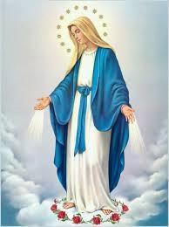

Blessed Virgin Mary

Deep religious convictions are evident with the Columbiettes: mass attendance; retreats;

## Membership Requirements



A Columbiette must be at least 18 years of age in full communion with the Catholic Church. You need not be married to, nor related to a Knight to be eligible to join.

**Our Patronesses**

Blessed Virgin Mary

St. Therese, the Little Flower St. Joan of Arc

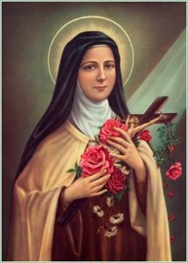

St. Therese, the Little Flower

.

blood drives; supporting unwed mothers; helping the needy; and helping the mentally and physically challenged.

Columbiettes are very active in our parishes. We can be found singing in the choir, serving as Eucharistic Ministers, Lectors, serving on the Bereavement Committee, working in the nursery and serving as Catechists and aides in the Faith Formation Program. Many members serve on the various committees of their parish.

**Join the Columbiettes**

**Help us make a difference by touching hearts and changing lives.**

We are ordinary ladies who are proud of reaching out and helping those less fortunate by meeting the needs of the people in their communities and around the world. We are also committed to the preservation of family life. We are an organization that addresses the religious needs of the church and community where we live, worship, work and play.